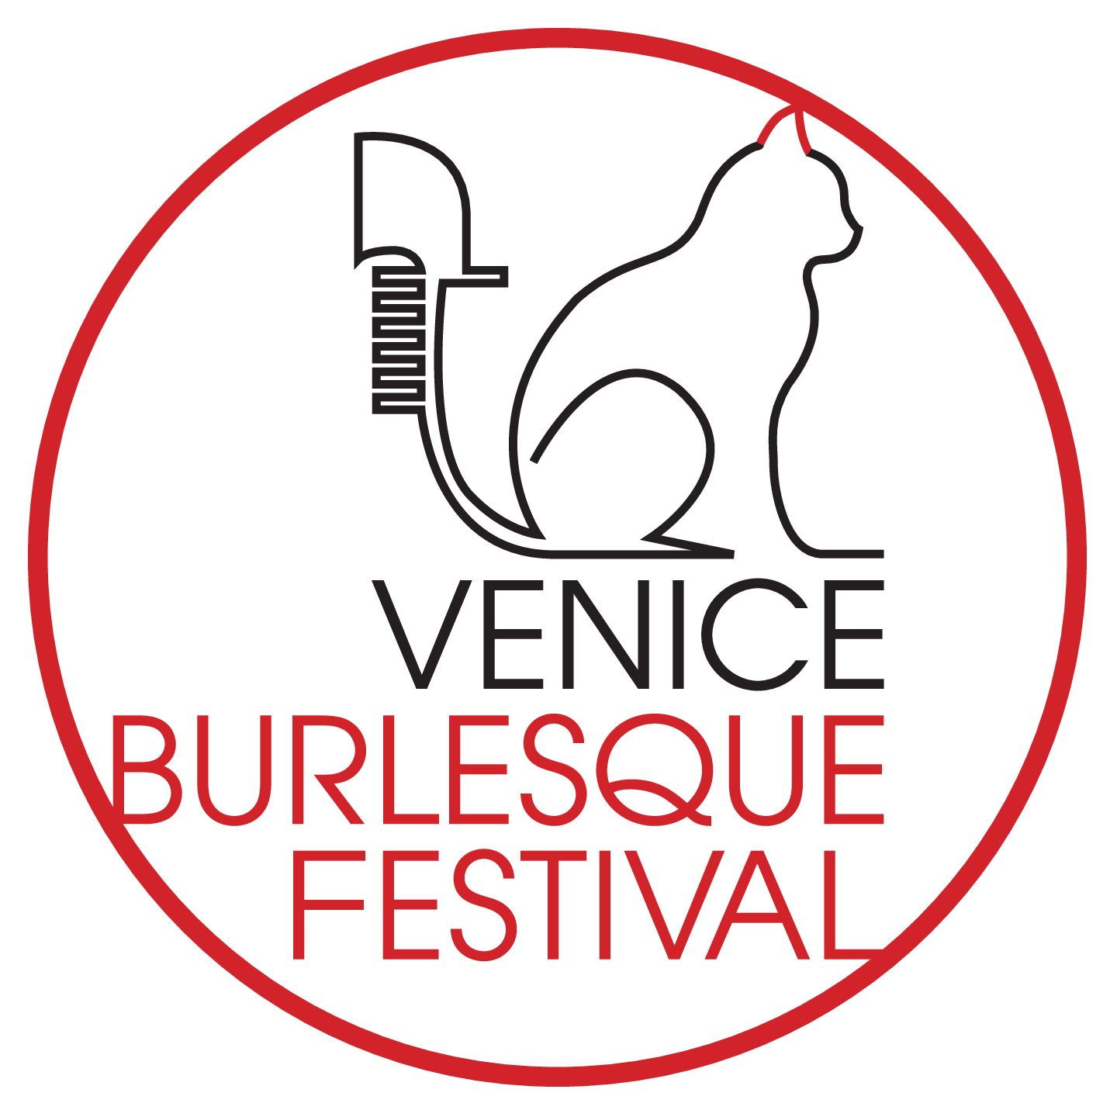

**Venice, Teatro A L’Avogaria**

**Saturday, January 18, 2025**

**RULES AND APPLICATION**

**Application opening**: July 1, 2024

**Application deadline:** September 15, 2024

**Notification of selected applications:** September 30, 2024

**How to apply:**

Send your application to i**nfo@veniceburlesquefestival.it,** attaching the completed application

form in PDF format and the receipt of the registration fee payment.

**Registration fee:**

● The €20 fee is non-refundable.

● Payment must be made via www.PayPal.com to **paypal@iantichi.org** from the same email

address used to send the application (if this is not possible, please clearly note both in your

application and in your payment that you are using a different name).

● Make sure to note your legal name and performer name in the payment.

● IMPORTANT NOTICE: Do not forget to include the PayPal receipt in the application email.

**Commitment:**

● If you are selected to perform at the VBF, you must confirm by **Sunday, October 6,** by

sending an email with your MP3 music file (rename your music as yourstagename.mp3), 2

web-resolution photos (1 headshot, 1 full-length), and 1 high-resolution photo (minimum 300

dpi) (rename your file as yourstagename).

● If we do not receive your confirmation by **Sunday, October 6,** your spot will be given to

another applicant.

● If for any reason you cannot fulfill your confirmation to participate in the VBF, let us know as

soon as possible. Failure to do so will result in your application not being considered in future

VBF editions.

● You cannot perform in similar events 7 days before or 7 days after the VBF in Veneto.

● All correspondence between performers and VBF, including the application, is confidential

and must not be shared with third parties before, during, or after the festival.

**Expenses/payments and invoices:**

VBF does not cover any of your expenses related to the festival (travel, hotel, or meals).

**Choreography characteristics:**

● Nudity: Full nudity is NOT allowed.

● Fire: Fire is allowed in the theater.

● Aerial: Aerial performances are allowed in the theater.

● Glitter: It is necessary to specify if the choreography includes the use of glitter or other sticky

or slippery substances.

● No choreography changes: The choreography selected through the video must be

performed without changes.

● Duration: The choreography must last a maximum of 6 minutes.

**Video:**

The application must include a link to the video of the choreography you wish to perform. The

quality of the video/lighting/background, etc., is not important; we need to see your entire

choreography without edits. It is important that the video link is not password-protected and

does not expire. We recommend easy-sharing sites like YouTube or Vimeo. Do not use

sharing sites that require registration, like Facebook or Dropbox. Downloadable videos will not

be considered.

**Complimentary tickets:**

● Complimentary tickets are not offered to family members or friends, who must purchase a

ticket to attend the VBF.

**Communications:**

● Correspondence will be sent via email, WhatsApp, or the dedicated Facebook page.

● For personal questions or concerns, please send an email to info@veniceburlesquefestival.it

or for emergencies, call **0039 3397337707.**

**Photos/Videos during the VBF:**

● By submitting the signed application form, you consent to being photographed and filmed

during the VBF and that your image may be used to promote the festival.

**Venues and technical information:**

Technical information regarding the stage, lighting, venue access, dressing room, etc., will be

sent later.

Lighting requests will be considered if possible.

The theater is not always available, and VBF does not have additional equipment for

choreographies. If you need extra equipment, you must request it immediately after

confirmation.

No assistants/personal helpers are allowed unless authorized.

**Rehearsals:**

Technical rehearsals for your choreography will be possible at the venue on the day of the

VBF. Rehearsal times will be strict and subject to changes. Rehearsal schedules will be sent

before the start of the VBF.

**APPLICATION**

NAME:

SURNAME:

PERFORMER NAME:

EMAIL:

PHONE:

CITY:

COUNTRY:

FACEBOOK PAGE:

INSTAGRAM PAGE:

WEBSITE:

SHORT BIOGRAPHY (for the presenter, max 60 words):

HOW LONG HAVE YOU BEEN PERFORMING BURLESQUE:

IMPORTANT EVENTS YOU HAVE PARTICIPATED IN (festivals, big shows, etc.):

TITLES YOU WON:

**ROUTINE 1:**

Link to video:

Name:

Duration:

Title and artist of the music (music must be mixed into one track):

Entry (“on stage,” “walk on music”):

Description of the choreography (for the presenter, max 60 words):

Description of the costume (colors, style, and list of pieces to pick up):

Any technical requirements or requests for assistance on stage:

Use of liquids, glitter, confetti, or other material to be cleaned after the choreography:

Lights (colors and notes) (we will try to meet your needs, but if you have very specific needs, it

is important to inform us in time so that we can understand if they are achievable):

**ROUTINE 2:**

Link to video:

Name:

Duration:

Title and artist of the music (music must be mixed into one track):

Entry (“on stage,” “walk on music”):

Description of the choreography (for the presenter, max 60 words):

Description of the costume (colors, style, and list of pieces to pick up):

Any technical requirements or requests for assistance on stage:

Use of liquids, glitter, confetti, or other material to be cleaned after the choreography:

Lights (colors and notes) (we will try to meet your needs, but if you have very specific needs, it

is important to inform us in time so that we can understand if they are achievable):

Place and date

_____________________

Signature

_____________________